useMemo Hook:

🔗 Connect with Me:  
🌐 LinkedIn : https://www.linkedin.com/in/priya-bagde  
📂 GitHub : https://github.com/priya42bagde  
💻 LeetCode : https://leetcode.com/priya42bagde/  
🎥 YouTube Channel : https://youtube.com/channel/UCK1_Op30_pZ1zBs9l3HNyBw (Priya Frontend Vlogz)

**What’s useMemo hook:**

It’s a hook which is used in **functional component** and return the **memoised value**, where we are **caching the value**, so that it doesn’t need to be **recalculate it**, it’s **based on the dependency change**, and it will help **to improve the performance**.

**When to Use useMemo:**

* When you deal with **heavy computations**.
* When the **same computation is repeated multiple times** and **returns the same result for the same inputs**.
* When **rendering large lists or data grids** and you want to avoid unnecessary re-renders.

**When Not to Use React useMemo:**

We should not use useMemo **for memoizing a function such as a callback**.

**How is it work:**

**const memoizedResult = useMemo(function, dependencies);**

* During **initial rendering**, useMemo(function, dependencies) invokes function, **memoizes the calculation result**, and returns it to the component.
* If the **dependencies don't change** during the next renderings, then useMemo() doesn't invoke function, but **returns the memoized value**. But if the **dependencies change** during re-rendering, then useMemo() invokes function, **memoizes the new value, and returns it**.
* If you pass an **empty array** ([]) as the dependencies, the memoized value will be computed only once during the initial render and will remain the same for subsequent renders.

**Difference between useMemo vs useEffect:**

It's important to note that we shouldn't add any code to useMemo that we **don't want to be run when the page or component is being rendered**. **Any code that affects another component than the current one** (called side effects) **should be kept in a useEffect**.

**Difference between useMemo vs useCallback:**

The useCallback hook allows you **to memoize the entire function**, and the useMemo hook allows you to **memoize the output of functions.** Also, let’s have the difference between while using it.

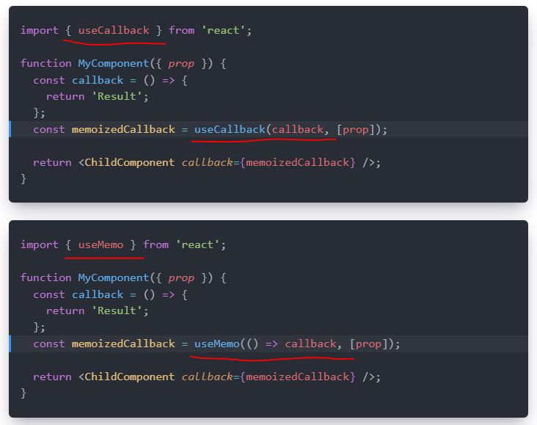

**Example:**

Suppose you have an **increment and decrement counter**. Also, you have a **multiply function**. Now when you **call the multiply function where we are multiplying with the increment (i.e, no usage of decrement).** When you click the increment button the multiply function will get call which is as expected because we are using the increment, but **when you click on decrement button then there is a multiply function ALSO, getting call**.**WHY ?**

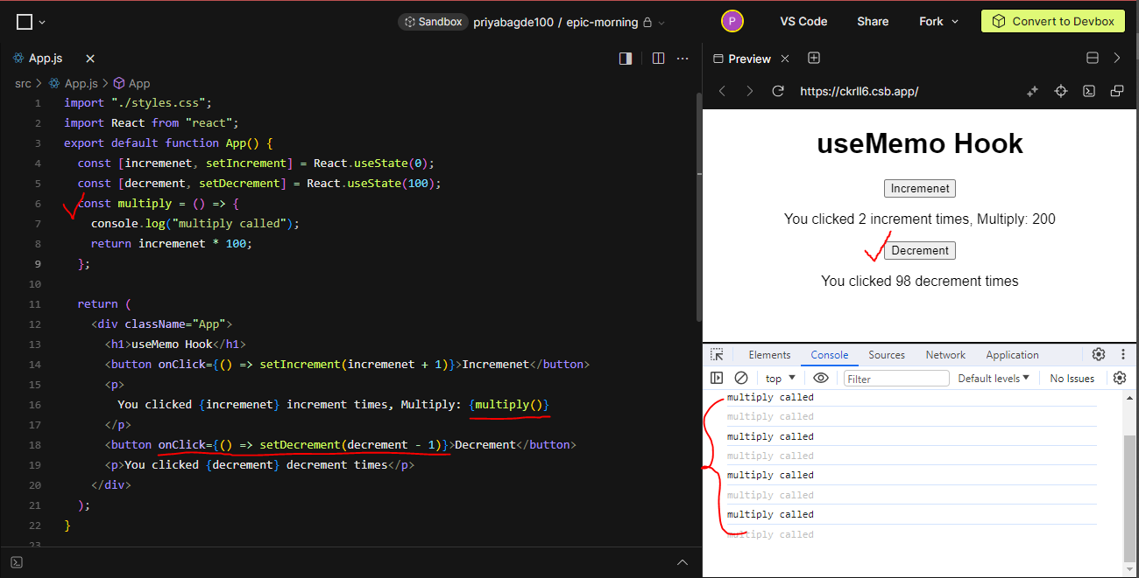

You can restrict the Multiply function to get call on decrement button **using the useMemo hook**, where you need to pass the dependency array and based on the dependency it will call.

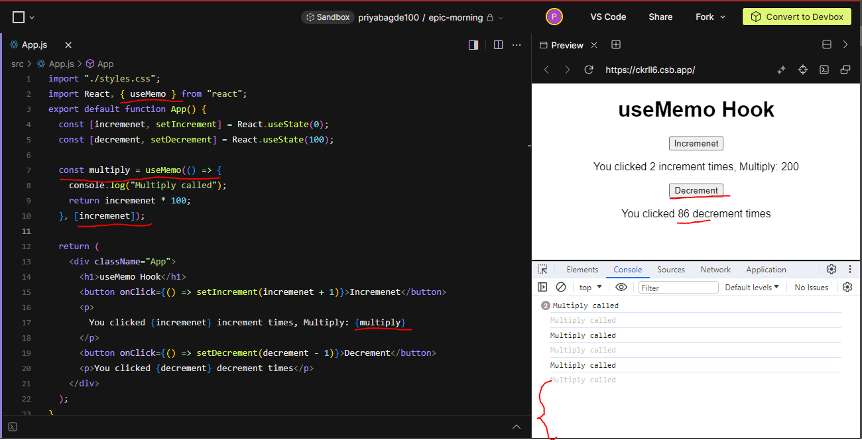

**What’s the difference between useMemo and React.memo in reactjs:**

